# RECIPE FINDER WEBSITE

# (DAINTY DELIGHTS)

### A MINI PROJECT REPORT

#### Submitted by

#### Group: G26

**DEEYA JULKA, Rollno. 2410992708**

**BEANT KAUR, Rollno. 2410992695**

**ARSHPREET KAUR, Rollno. 2410992687**

#### in partial fulfillment for the award of the degree of

## BACHELOR OF ENGINEERING

***in***

CSE-AI



**CHITKARA UNIVERSITY**

**CHANDIGARH-PATIALA NATIONAL HIGHWAY**

**RAJPURA (PATIALA) PUNJAB-140401 (INDIA)**

##### NOVEMBER,2024

###### **TABLE OF CONTENTS**

|  |  |  |
| --- | --- | --- |
| Sr.no | Section | Page no. |
|  | Abstract | 3 |
|  | Introduction | 4 |
|  | Problem Statement | 5-6 |
|  | Technical Details | 7-8 |
|  | Key Features | 9 |
|  | Project Advantages | 10 |
|  | Bonus Features | 11 |
|  | Project Highlights | 12-21 |
| **9.** | Conclusion | 22 |
| **10.** | Reference | 23 |

**ABSTRACT**

Dainty Delights – A Baking Heaven

Dainty Delights is an innovative recipe finder platform designed to simplify and enhance the baking experience for home bakers. This website provides an extensive selection of recipes catering to diverse tastes, skill levels, and dietary preferences. It empowers users with features like ingredient-based recipe searches, advanced dietary filters, recipe customization, and a shopping list generator.

The project addresses common challenges faced by bakers, such as managing pantry ingredients, catering to dietary restrictions, and overcoming decision fatigue. The website leverages modern web technologies, including HTML, CSS, JavaScript, and API, to deliver a dynamic, responsive, and visually appealing user experience. Key functionalities include:

• Ingredient-Based Recipe Search: Find recipes using available ingredients, reducing waste and grocery trips.

• Dietary Preference Filters: Tailored options for vegan, gluten-free, and other dietary needs.

• Interactive Shopping List: Auto-generated lists for seamless ingredient organization.

• Recipe Sharing: share recipes with friends and family.

• Expert Baking Tips: Guides to enhance baking skills and creativity.

With dedicated sections for cakes, cookies, breads, shakes, pastries, and Indian sweets, the platform showcases a comprehensive range of recipes accompanied by detailed instructions.

Dainty Delights aims to minimize food waste, encourage health-conscious baking, and streamline the preparation process. Future developments include enhanced API integration, more advanced filters, and personalized recommendations. Dainty Delights aspires to remain a trusted companion for home bakers, fostering creativity and ease in every culinary adventure.

**1.INTRODUCTION**

In the fast-paced world of today, cooking can frequently seem like an overwhelming undertaking. Finding meals that fit their dietary restrictions and accessible supplies is a challenge for many home cooks.

* 1. KNOW MORE ABOUT OUR WEBSITE: -

DAINTY DELIGHTS (A BAKING HEAVEN)

'Dainty Delights' is an attempt to make cooking easier, especially for those who enjoy baking, by offering an intuitive interface that lets users find mouth-watering recipes customized to their preferences.

A recipe search engine on the internet created especially for those who enjoy baking is called Dainty Delights. The website provides a well-chosen selection of baking recipes to suit different tastes and abilities.

Dainty Delights offers users healthy options, ingredient suggestions, and simple-to-follow directions in an effort to streamline baking and stimulate culinary creativity.

1.2 THE PRIMARY GOAL WE SEEK: -

1.2.1 Enable users to input the ingredients they have on hand, allowing the app to fetch and display relevant recipes from a connected recipe API.

1.2.2 Include options for users to specify dietary preferences (e.g., vegetarian, vegan, gluten-free) to ensure that the recipes provided align with their individual needs.

1.2.3 Design the app with HTML and CSS to create a visually appealing, responsive layout that enhances user experience across various devices.

1.2.4 Implement functionality that allows users to save their favorite recipes for easy access later, encouraging continued engagement with the app.

1.2.5 Facilitate users in sharing their favorite recipes with friends and family.

1.2.6 Provide users with the ability to create a shopping list based on the ingredients required for selected recipes, making meal preparation more organized and efficient.

1. **PROBLEM STATEMENT**

2.1. Home bakers frequently encounter obstacles such as:

### 2.1.1. Ingredient Utilization Challenges:

### Home bakers often struggle to locate recipes that make optimal use of the ingredients they already have, leading to unnecessary trips to the store or wasted ingredients.

### 2.1.2. Difficulty in Catering to Dietary Restrictions:

### Finding recipes that cater to specific dietary needs such as gluten-free, vegan, or other restrictions can be time-consuming and frustrating for bakers with special requirements.

### 2.1.3. Overwhelming Choice and Decision Fatigue:

### With an abundance of recipe options available, home bakers often feel overwhelmed, making it difficult to choose what to bake, leading to confusion and indecision.

### 2.1.4. **Lack of Personalization**:

### Many baking platforms do not offer personalized recipe suggestions

### based on user preferences, leading to irrelevant or unappealing

### options.

### 2.1.5. Difficulty in Managing Ingredients:

### Managing a pantry and ensuring ingredients don't go to waste can be a struggle, especially when recipes don’t align with what's available at home.

### 2.2. Proposed Solution:

### 2.2.1 Allow users to enter the ingredients they have on hand, automatically filtering recipes that match those ingredients.

### 2.2.2. Offer advanced filtering options for dietary restrictions and preferences, ensuring that users only see recipes suited to their needs.

### 2.2.3. Automatically generate a shopping list for users based on the recipes they choose, helping them save time and stay organized.

### 2.2.4. By addressing common frustrations faced by home bakers, ‘Dainty Delights’ makes the baking process smoother, more enjoyable and rewarding

### 3. TECHNICAL DETAILS: -

### 3.1. Technical Overview:

### The Dainty Delights website was built using the following technologies:

### 3.1.1 HTML: To structure the layout and content of the web pages.

### CSS: To style the visual appearance and ensure responsiveness across different devices.

### JavaScript: To handle user interactions, dynamic content updates, and API calls.

### Recipe API: To access a vast database of recipes and retrieve relevant data based on user search criteria.

### 3.2. Development process and Technology Stack:

### The development of Dainty Delights followed an iterative design and development process. The initial stages involved:

### 3.2.1 User Research: Understanding the needs and preferences of baking enthusiasts to inform the design and features of the platform.

### 3.2.2 Wireframing: Creating low-fidelity mockups to visualize the layout and structure of the website.

### 3.2.3 Prototyping: Developing interactive prototypes to test the usability and functionality of the features. Once the design was finalized, the development team focused on.

### 3.2.4 API Integration: Integrating the recipe API to retrieve and display relevant recipes based on user searches.

### 3.2.5 User Interface Development: Building a visually appealing and user-friendly interface that is easy to navigate.

### 3.2.6 Feature Implementation: Implementing key features such as ingredient search, dietary filters, and recipe customization.

### 3.2.7 Testing and Optimization: Thoroughly testing the website to ensure it functions correctly and optimizing performance for a smooth user experience.

**4. Key Features**

### Dainty Delights offers a range of features to enhance the baking experience:

4.1Ingredient**-BasedSearch**  
Users can effortlessly search for recipes using the ingredients they have on hand, eliminating the need for last-minute grocery runs. This feature helps reduce food waste by suggesting creative recipes that align with the available pantry items.

4.2Advanced **Dietary Filters**  
Dainty Delights offers robust filtering options to cater to various dietary preferences and restrictions. Whether users are looking for vegan, gluten-free, lactose-free, or low-sugar recipes, they can easily find options that meet their specific needs.

4.3 Recipe **Customization**  
With the ability to adjust ingredient quantities and substitute alternatives, users have the flexibility to tailor recipes to their personal tastes or dietary requirements. This makes each recipe highly adaptable and personalized for every baker.

4.4 Baking **Techniques**  
Users have access step-by-step baking techniques, guiding them through complex recipes and improving their overall baking skills. From mastering the perfect cake rise to achieving a flawless cookie texture, these insights help users at all skill levels.

4.5 Interactive **Shopping List**  
Automatically generate a shopping list for the ingredients needed in selected recipes. This feature simplifies grocery shopping by providing an organized list, ensuring that users can gather all necessary ingredients in one trip.

4.6 Recipe **Sharing**  
Share delicious discoveries with friends and family through integrated social sharing options. Users can share their favourite recipes via social media, email, or direct links, making it easy to spread baking inspiration.

**5. Project Advantages**

5.1 MinimizedFood Waste:

* By focusing on recipes based on available ingredients, the platform helps reduce food waste and encourages resourceful baking.

5.2 Health**-**Conscious Baking:

* With personalized dietary filters, users can enjoy baking while maintaining their health goals and dietary restrictions.

5.3 Time**-**Saving:

* The platform consolidates multiple features (recipe search, dietary filters, shopping list creation) into one easy-to-use interface, saving users time and effort.

5.4 EnhancedUser Experience:

* By addressing common frustrations faced by home bakers, 'Dainty Delights' makes the baking process smoother, more enjoyable, and rewarding.

**6. Bonus Feature**

**6.1.** **Save and Share Favorite Recipes**  
Users can easily save their favorite recipes for quick access, creating personalized recipe collections. Additionally, with seamless social media integration, users can share their favourite recipes with friends and family via platforms such as Facebook, Instagram, or WhatsApp, enhancing community engagement and baking inspiration.

**6.2.** **Shopping List Generator**  
Once users select a recipe, the platform automatically generates a comprehensive shopping list based on the ingredients needed. This feature helps users streamline their grocery shopping by listing all the items required for their selected recipes, ensuring that they don’t miss a single ingredient.

**7. Project Highlights**

7.1. Homepage Overview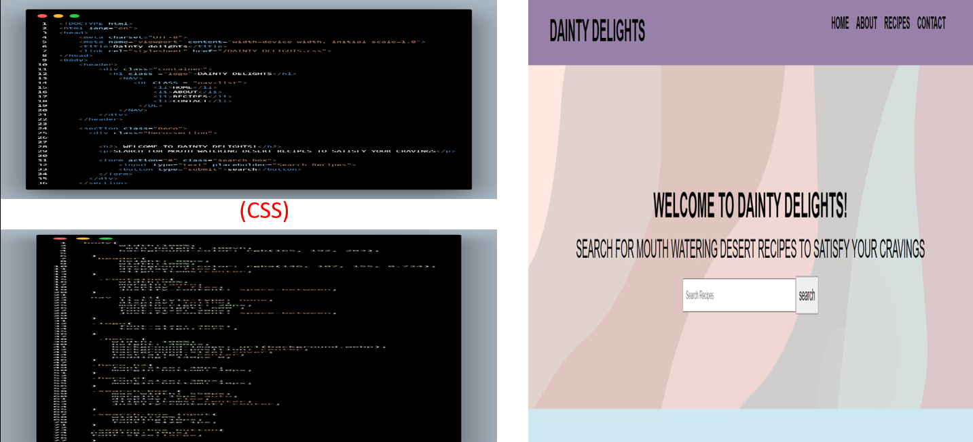:-

A beautifully crafted homepage combining functionality and elegance with a site name, search bar, navigation menu, and contact details.

7.2 Cakes page overview: -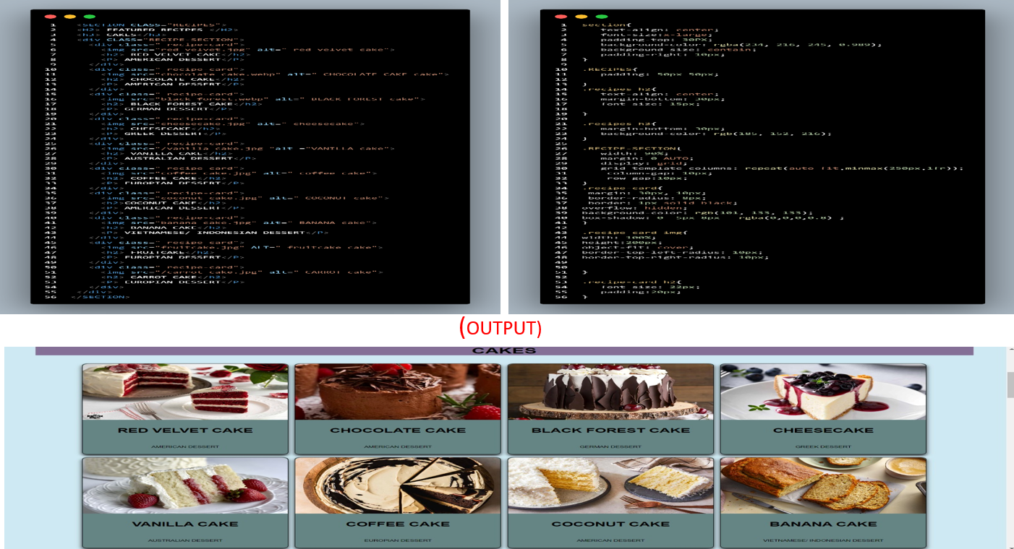

Explore the Cakes segment on Dainty Delights for detailed recipes and step-by-step guides to bake perfection at home.

7.3. Cookies Section Overview: -

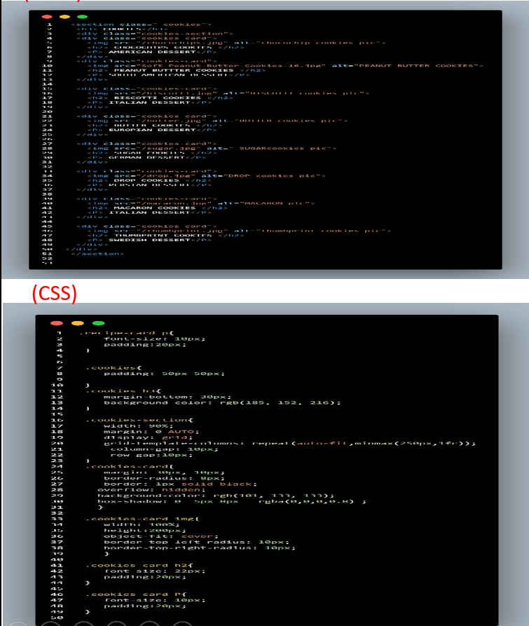

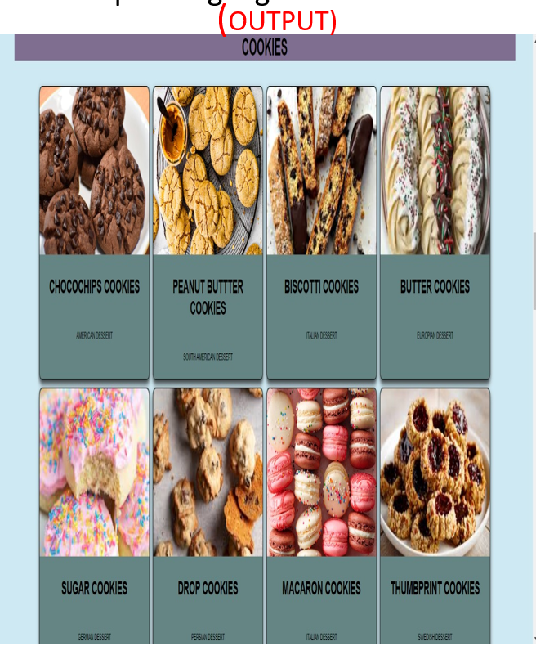

A cookie lover's paradise: Dive into the Cookies section of Dainty Delights, featuring recipes from classic to creative for every occasion.

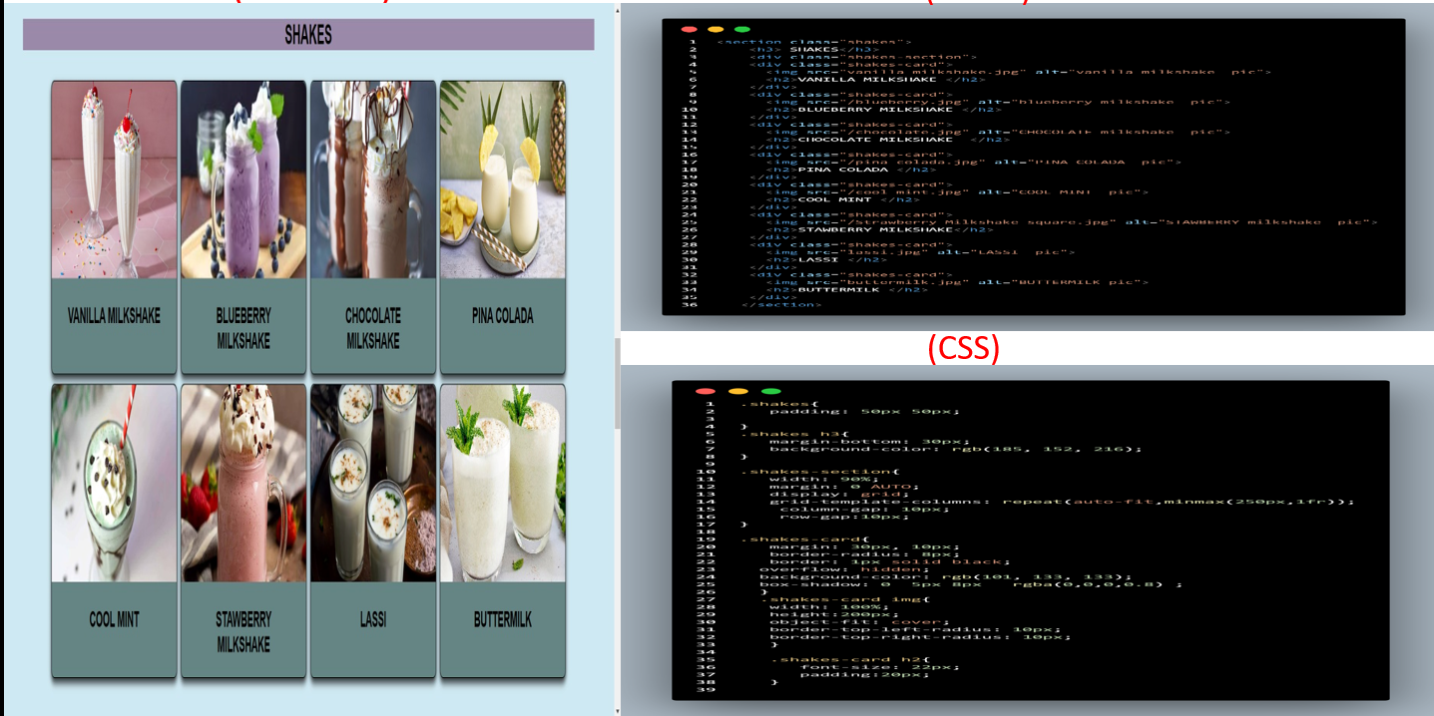7.4. Shakes Section Overview: -

Quench your thirst with the Shakes section of Dainty Delights, offering recipes from classic milkshakes to nutritious smoothies.

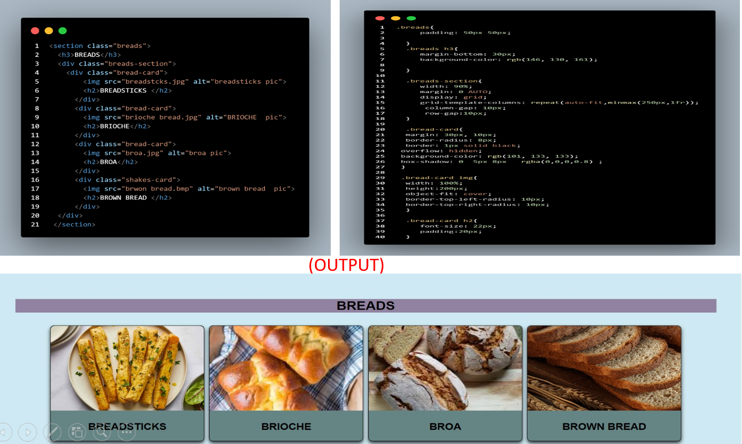7.5. Breads Section Overview:-

Master the art of bread-making with Dainty Delights' Breads section, featuring recipes for everything from soft loaves to crusty artisan breads.

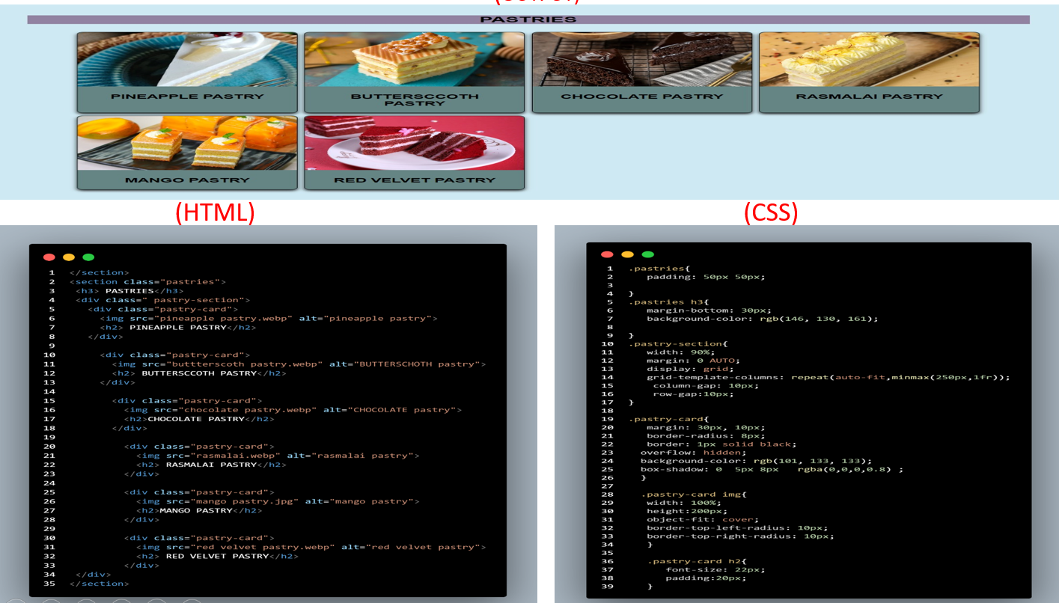7.6. Pastries Section Overview: -

Indulge in the Pastries section of Dainty Delights, featuring recipes for everything from delicate puff pastries to rich, buttery croissants.

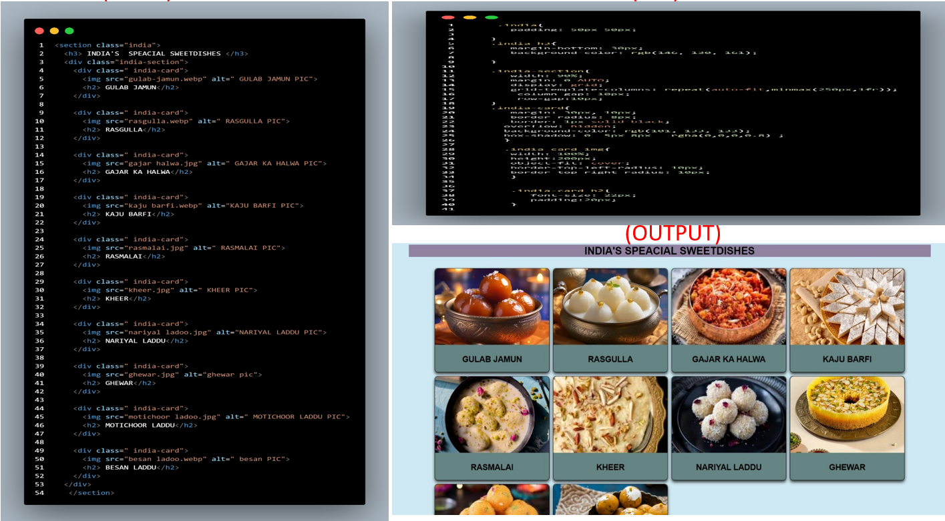7.7. Indian Special Sweet Dishes Section Overview:

Savor the flavors of India with Dainty Delights' Indian Special Sweet Dishes section, offering traditional and regional desserts for every occasion.

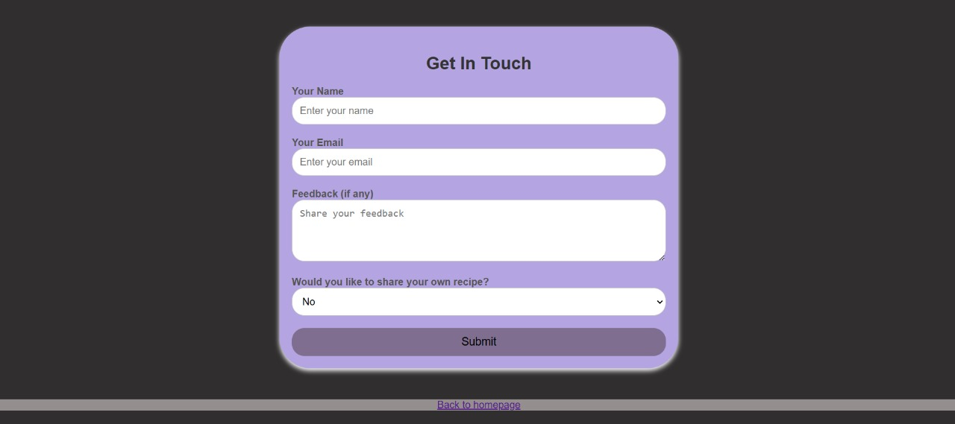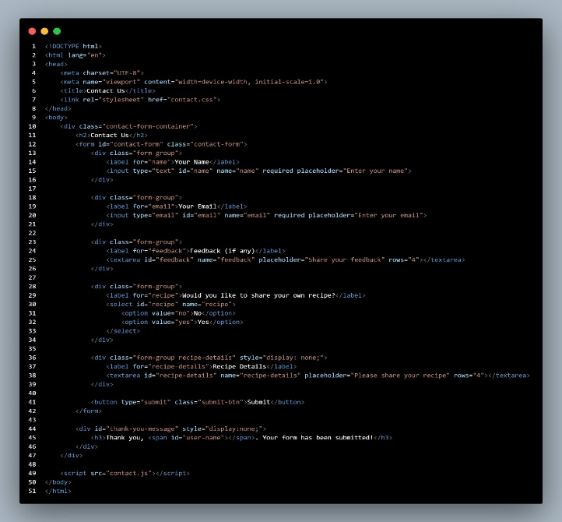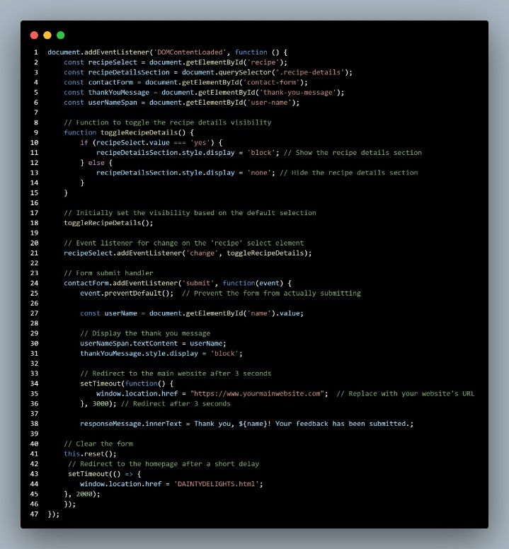7.8 Contact us page: -

Engage with Dainty Delights through the 'Contact Us' page, where you can share your feedback, recipes, and reach out via email.

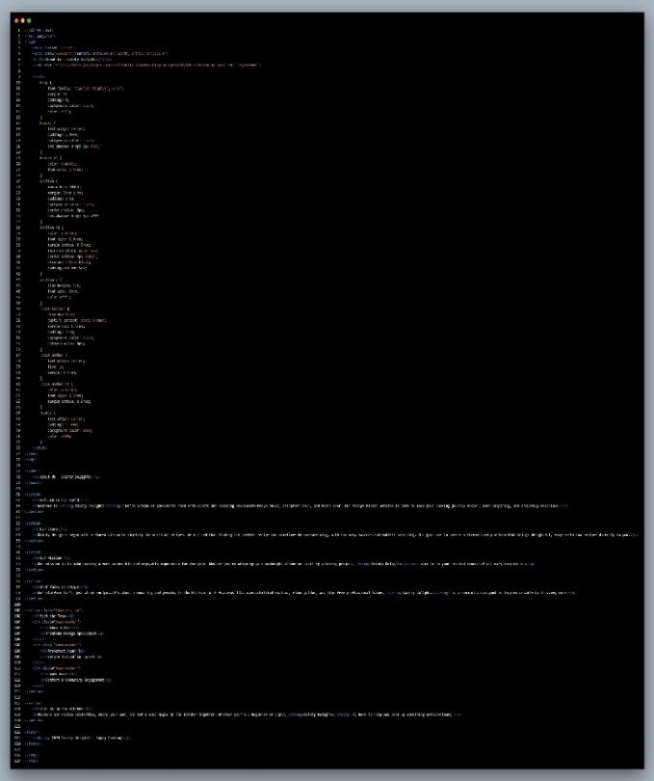7.9 About us: -

Discover the heart of Dainty Delights on our 'About Us' page, where we share our story, mission, uniqueness, and introduce our team.

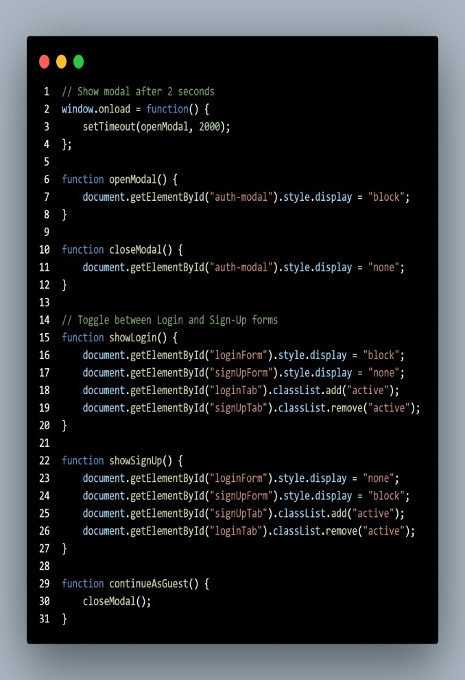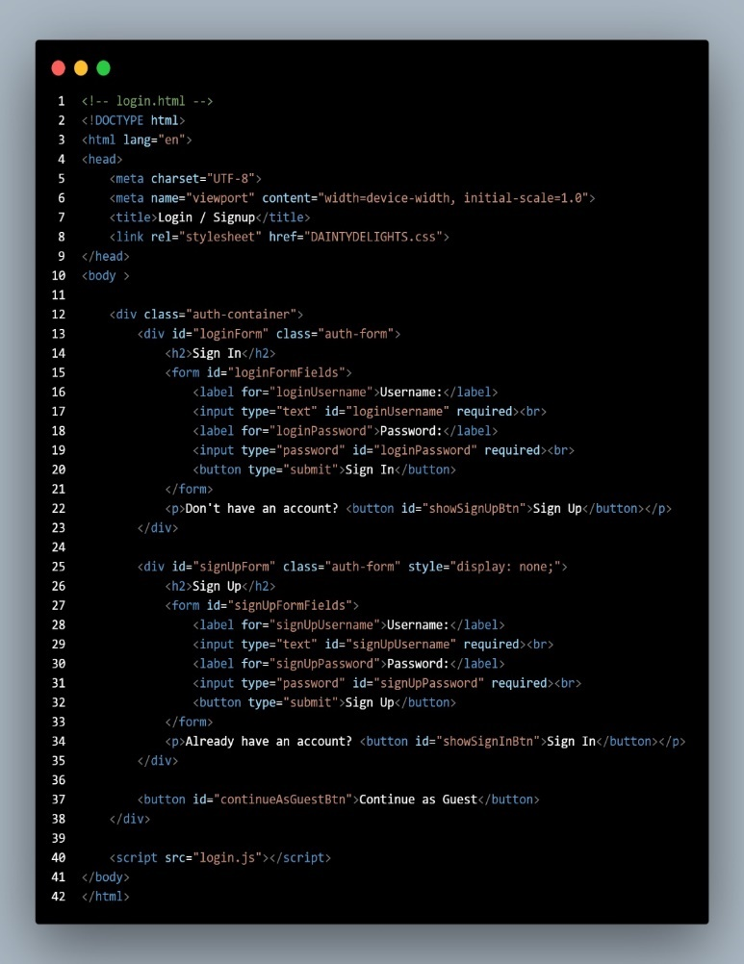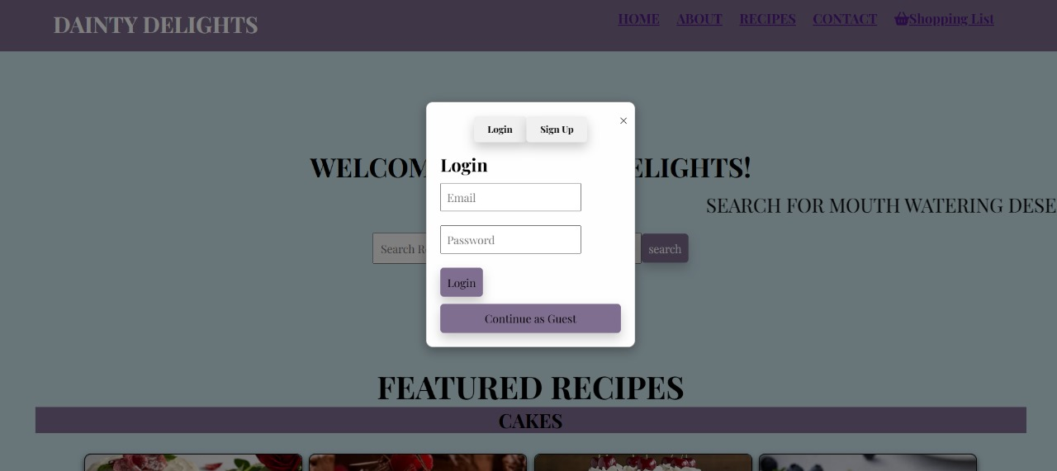7.10 Login: -

Seamlessly access your account with the Login/Sign-Up pop-up form that appears upon entering the Dainty Delights website.

**8. Conclusion: -**

Dainty Delights has successfully established itself as a valuable resource for baking enthusiasts by offering a user-friendly interface, an extensive recipe database, and a range of practical features. The platform empowers users to explore their culinary creativity with convenience and inspiration. As the baking community continues to grow, Dainty Delights remains committed to expanding its offerings and providing innovative solutions.

These advancements will help ensure Dainty Delights continues to be a trusted destination for home Bakers, providing both convenience and inspiration in their culinary adventures.

**9.Reference: -**

* 1. **Helpful tutorials and guides**

[**https://www.geeksforgeeks.org**](https://www.geeksforgeeks.org)

* 1. **Image sources**

[**https://www.pexels.com**](https://www.pexels.com)

[**https://pixabay.com**](https://pixabay.com)